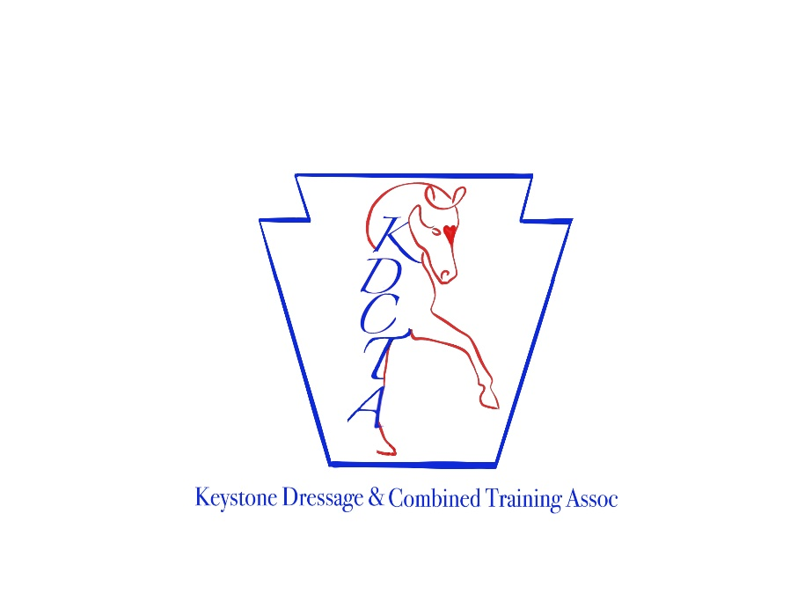
KDCTA Working Equitation
Obstacle Play Day
June 28 & Aug 30, 2025 at Blue Barn Farm
8001 Berwick Forge Rd, Huntingdon, PA 16611
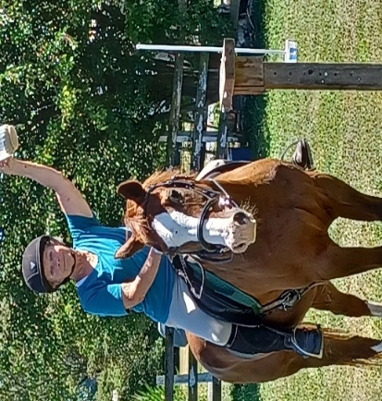
Jug Obstacle
Want to learn more about working equitation obstacles? Come to a play day and learn the rules and how to ride them. 90 min sessions with 3-4 riders per session.
KDCTA Members are FREE- complete the registration link below.
Non KDCTA Members – $25, please complete the registration link below. Pay day of with check or cash.

Limited stalls available. Contact: Stephanie Dobiss kdcta11@gmail.com www.KDCTA.org

Register Here for Aug 30th: https://forms.gle/9SHGRAPE5YG6NgUZ9

